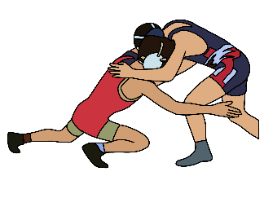
The Christian Orozco Scholarship is a testament to the impact that one person can have on their community. Christian Orozco was not only a talented wrestler but also kind, compassionate individual who touched the lives of everyone he met. His family established this scholarship in his memory, to continue the legacy of helping others that he believed in.
Chris was the epitome of a leader, always leading by example and uplifting others. He had a passion for life that was infectious, and he loved nothing more than wrestling. As a Team Captain at Saginaw High School, he inspired his teammates to give their all and to never leave anyone behind. His dedication and love for the sport continued into college at Wayland Baptist University, where he pursued his dream of wrestling.
Despite his untimely passing, Chris’ impact on the Saginaw community and beyond will never be forgotten. He was a son, a brother, and a teammate who always put others first, and he touched so many lives in such a short time. His family established this scholarship to continue the work that Chris started, to help others and make a difference in the world.
We urge any graduating senior wrestler at Saginaw High School who is planning to attend college to apply for this scholarship. The Christian Orozco Scholarship is a $500 award that will be given to one person on the boys wrestling team and one person on the girls wrestling team, chosen by Chris’ Family.
We believe that through the Christian Orozco Scholarship, we can make a difference in the lives of young wrestlers who are pursuing their dreams. By supporting this scholarship, you are investing in the future of our community and helping to ensure Chris’s legacy of kindness and compassion lives on. We ask for your generosity and support as we work to continue what Chris believed in – helping others.

Eligibility: This scholarship will be awarded to a Saginaw High School wrestling graduating senior planning to attend a university.
Award Criteria: Involvement in extracurricular and/or community activities High standards of personal conduct, character, and integrity.

Application Procedure:
1. Complete the application form and essay. Please include a short, typed essay of no more than 250 words indicating your future academic and personal goals.
2.Include two letters of recommendation. Obtain two letters of recommendation from non-relatives who are members of your community and who can attest to your character, school and/or community involvement and potential for future success.
3.Submit application to Coach Redden Saginaw High School Wrestling Coach
*Include any additional information you would like to have considered on your application.
Deadline: April 21, 2025
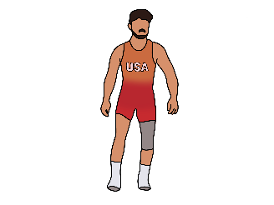

Student Name: _____________________________________________________
Street Address: __________________________________________
City _________________________________ Zip code: _____________
Telephone Number: _______________________________
Parent’s Name: _________________________________________________
Parent’s Address: _______________________________________________
High School Anticipated graduation date: ____________________________GPA __________
College Attending: ______________________________________________
Degree being pursued: __________________________________________

High School activities in which you have been involved: Community activities in which you have been involved.
________________________________________________________________________________________________________________________________________________________________________________________________________________________________________________________________________________________________________________________________________________________________________________________________________________________________________________________________________________________________________________________________________________________________________________________________________________________________________________________________________________________________________

I certify that the information I have provided is complete and correct to the best of my knowledge. I also authorize the release of information concerning the application.

Signature:____________________________________Date:_________________

